Name: _____________________________ /35

Year 7 Investigating Science Practical Test

- This test has 4 parts.

- At some stage during the lesson you will be instructed by your teacher to get up from your desk and start on the Practical section. You will have 15 minutes to work on the Practical section then you will be asked to sit in your seat again and continue with the other sections.

- You can work through the Practical section in any order, you don’t have to start at station number 1.
…………………………………………………………………………………………….
Multiple Choice Answer Sheet

Please circle the correct answer. If you make a mistake cross it out and circle the correct answer. If you think your teacher may not know which answer you mean write the correct letter next to the questions number.

Do not leave any answers blank. If you don’t know the answer, just choose the best one then you still have a chance of getting it correct.

- A B C D

- A B C D

- A B C D

- A B C D

- A B C D

- A B C D

- A B C D

- A B C D

- A B C D

10 A B C D
Multiple Choice
1 mark per question
Remember to use the answer sheet on the previous page.

- Which diagram of a beaker is the best one?
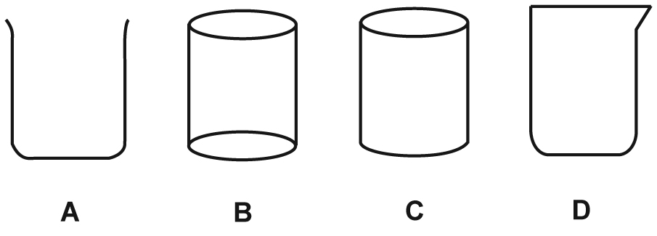

2 A student had a 500 mL beaker, and wanted to heat 250 mL of water in it. What other equipment would they need?
a Bunsen burner, retort stand, wire mat, clamp and boss head
b tripod stand, Bunsen burner, tongs, retort stand
c tripod stand, wire mat, Bunsen burner, safety mat
d Bunsen burner, tongs, safety mat, tripod stand

4 If you were washing up after an experiment, and had a test tube with a solid and liquid in it, what should you do?
a Wash the test tube contents down the sink with plenty of water.
b Tip the liquid in the sink and the solid in the bin.
c Put the test tube and its contents on the teacher’s tray.
d Tip the test tube contents in the bin.

5 Following is a list of steps in lighting a Bunsen burner. The steps are in the WRONG ORDER.
1 | Turn on the gas
2 | Tie back long hair, wear safety glasses and use a bench protector
3 | Close the air hole with the collar
4 | Light the match and hold it near the top and at the side of the Bunsen burner
What is the CORRECT order for lighting the Bunsen burner, using the step numbers from the table above?
a 1, 2, 3, 4
b 3, 4, 2, 1
c 2, 3, 4, 1
d 2, 1, 3, 4
6 Which of the following units are used to measure mass?
a mL
b g
c ºC
d seconds

7 Which of the following laboratory instruments is NOT used for measurement?
a conical flask
b triple beam balance
c measuring cylinder
d thermometer

8 Which of the following units are used to measure temperature?
a mL
b g
c ºC
d seconds

9 Look at the diagram below of part of the scale on a measuring cylinder. What is the volume of water in it?
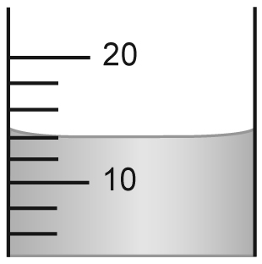
a 14 mL
b 15 mL
c 16 mL
d 18 mL

10 How long is the block of wood shown in the diagram below?

a 20 cm
b 25 cm
c 35 cm
d 45cm

Vocabulary
1 mark per question
Please write the correct term in the blank space

11 ________________ The curved shape on the surface of a liquid

12 ________________ Where Scientists work

13 ________________ A measure of how much matter is in an object

14 ________________ The Science of the planets, stars and the universe

15 ________________ The Science of forces and energy

16 ________________ Scientists who study living things

17 ________________ The flame produced when the holes are closed on
a Bunsen burner

18 ________________ The system of units used internationally by
Scientists

Graph
Please use the graph paper to draw your graph (5 marks)

Gertrude and Ernest wanted to see if 100mL of water would heat at an even rate over a Bunsen burner.
They heated the water and took the temperature of the water every minute.
The obtained the following results.

Heating 100mL of water
Time in Minutes | 0 | 1 | 2 | 3 | 4 | 5
Temperature in ºC | 25 | 40 | 55 | 70 | 85 | 100

Draw a graph of Gertrude and Ernest’s results.

Hint:
Decide on the type of graph
Work out how much space you need
Remember all the elements a good graph should contain
Practical

Station #1 (2 marks)

Name the piece of equipment being used ________________________

What is the mass of the item? ______________________

Station #2 (3 marks)

Name the piece of equipment being used ________________________

What is the volume of water in it? ______________________

Draw a scientific diagram of it

Station #3 (7 marks)

What is the temperature of the water? ________________________

What piece of equipment did you use to take this measurement? _______________

Describe how you took the temperature of the water

______________________________________________________________________

______________________________________________________________________

______________________________________________________________________

Draw a scientific diagram of this set up

Teacher Instructions for Practical Section

Station #1

A spring balance with an object they can measure the mass of.

Station #2

A measuring cylinder with a known volume in it

Station #3

Protective Mat, Bunsen burner, tripod, gauze mat, beaker of water and thermometer

Wanting them to mention, don’t touch the glass and allow time for the temperature to adjust before taking the reading.

